MAIDA HILL NEIGHBOURHOOD PLAN  What is the Neighbourhood Plan?  The Plan sets out policies to guide Westminster City Council’s decisions on new buildings, exterior refurbishments, and changes to streets and public spaces in Maida Hill.  The Plan also includes ambitions for new projects by Maida Hill Neighbourhood Forum and local stakeholders (such as the Council) to make the neighbourhood better for everyone. | 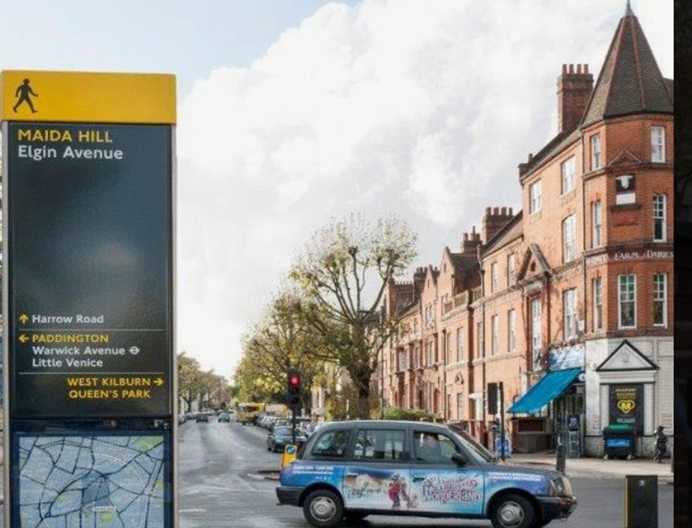
Written by people in Maida Hill for Maida Hill, the Plan outlines planning policy guidelines to:
- Protect and improve community facilities,
- Protect parks and introduce new green areas,
- Prevent overdevelopment,
- Allow careful development of roof terraces,
- Improve walking and cycling routes, and
- Adapt streets and public spaces to climate change.
Voting on the Plan
A Referendum on the Plan will be run by the Council. It will ask the question: Do you want Westminster City Council to use the Neighbourhood Plan for Maida Hill to help decide planning applications in your neighbourhood area?
All residents will get a chance to vote on the Plan. You will be told how to do this by the Council. We anticipate that the Referendum will take place later this year.
What is the Maida Hill Neighbourhood Forum?
The Maida Hill Neighbourhood Forum (MHNF) is a voluntary group of people living and working in Maida Hill. Endorsed by Westminster City Council, we have been active since 2015.
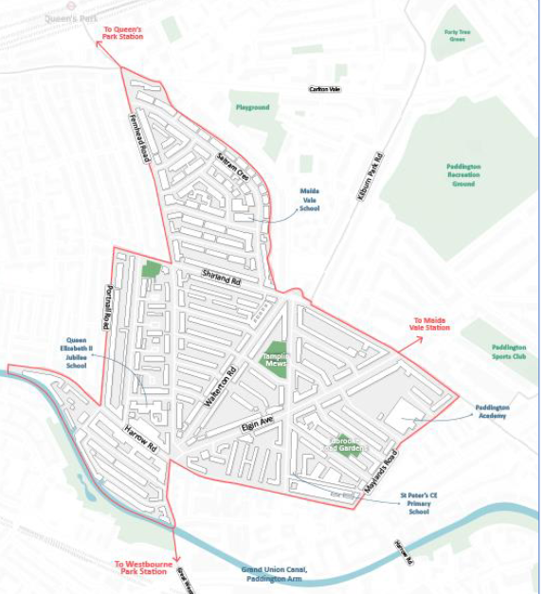

Summary of the Plan
The Plan covers policies on local facilities, housing, public spaces, green space and the environment, shops and cafes, and street traffic. Some policies involve local residents, others relate to local businesses. The Plan also shows that Maida Hill Neighbourhood Forum aims to undertake projects with local stakeholders.
Theme | Planning policies |  | Projects with local stakeholders
 | Residents | Businesses | Residents | Stakeholders
Facilities (e.g. community centres, sports areas) | Protect and expand local facilities  Protect important local buildings | Encourage affordable workspaces | Expand creation of small green spaces (‘parklets’) | Encourage stakeholders to undertake more community activities
Housing | Encourage affordable housing  New buildings design (including height) to reflect spirit of area  Roof extensions to respect spirit of area |  | Develop register of empty properties, so Council can take action faster | Support  enforcement action by the Council in tackling illegal holiday letting arrangements
Public spaces | Encourage better public access to Canal in new developments  Developments must be safe to use by all the community |  | Explore ways to open up new green spaces to the public | Encourage Council to invest in improving key road junctions
Green space and environment | Protect local parks  Preference for refurbishment over new build |  | Monitor air quality | Encourage “raingardens” to reduce flood risk
Shops and cafes |  | More outdoor seating & dining |  | Work with retail association to improve shop fronts
Street traffic | New developments to include well designed routes for cycling and walking |  | Advise council on parking  Better cycle and walking routes

